**LANGUAGES TRANSLATOR APPLICATION USING PYTHON**

**ABSTRACT**

This paper stresses the role of translation in teaching foreign languages. The student who practices translation improves his linguistic competence in two languages and therefore develops his bilingualism. It is necessary to resort to the most recent didactic, linguistic and psychological studies which all assert the importance of translation in the acquisition of a second language. As for the second question, it is necessary to draw on the pedagogy of translation in order to set the practice on sustainable foundations. In other words, we will try to show that the course of translation guides the learner to the conceptualization of linguistic systems, not through pure and simple correspondence, but through a comparative reflection emphasizing on the similarities and differences between the two languages put in parallel. Language Translation (LT) software today provides adequate conversion of foreign languages to one's native tongue; however, dialects, slang, and character conversion errors result in partially successful translations. For an accurate translation, a native speaker is often required to correct the translation by using sentence structure and word use cues to capture the true meaning. LT character conversion from Cyrillic, Asian, and Arabic languages to western characters induce errors in the translated text which can change the meaning or result in characters being associated together that do not form words. The authors present a solution using open source LT and the International Organization for Standardization (ISO) character mapping. The solution provides proper character conversion to achieve greater translation accuracy for web- based content.

**INTRODUCTION**

Translation is the process of conveying a written source language text clearly, completely, accurately, and appropriately in a target language.

Language Translation is the process of conveying a written source language text clearly, completely, accurately, and appropriately in a target language. Translation allows information to be transferred across languages, expanding accessibility of the information. The translation process involves translation, editing, and proofreading. Training programs at NMHSs may be able to use translation as a cost-effective means to expand their training program's

offerings. Translation is an activity, a product, and a process. As an activity, translation is a complex act that requires close reading of a text in the source language, understanding its meaning, and creating an equivalent text in the target language. The word "translation" also refers to the product of this activity: the final target language text that will be published or distributed. Although this document will touch on these aspects of translating, we will focus primarily on

the process of creating a translation, using this definition.

Today, translation is more widespread and accessible than ever before. Translation efforts can be organized in creative ways: organizations with larger budgets may choose to hire a translation company or independent professional translators to handle all of their translation needs; organizations with smaller budgets, or with subject matter that is not familiar to many translators, may decide to combine the services of professional translators with the skills of existing staff members; finally, organizations with a pool of expert volunteers may opt to include their services in the process. Whatever your budget and translation needs, there are ways to make it work.

**SCOPE**

The goal of translation practice for non-specialists is to found the language skills of the learner, to refine their thematic and cultural knowledge and to encourage them to think and to react.

The objective of language translator are:

1. Develop a system which able to do conversion between the languages.

2. Provide an easy and simple for translation.

3. Endow good experience to the user.

4. Translate almost each language.

As the internet continues to penetrate in emerging countries worldwide. Besides the top languages for translation, the software will have to provide accurate solutions to communicate with audiences who speak less known dialects.

**PROJECT DESCRIPTION**

**Project Overview**

The Language Translator project aims to create a tool that can translate text from one language to another using Python. This project leverages natural language processing (NLP) techniques and machine learning models to provide accurate translations. It is intended to be user-friendly and flexible, allowing for the addition of new languages and translation models as needed.

**Objectives**

* Develop a Python-based application capable of translating text between multiple languages.
* Utilize existing machine learning models and NLP libraries to ensure accurate translations.
* Create a user interface (UI) for easy interaction with the translation tool.
* Allow for scalability by supporting the addition of new languages and models.

**Features**

**1.Multiple Language Support**: Translate text between various languages such as English, Spanish, French, German, Chinese, etc.

**2.User-Friendly Interface**: A simple and intuitive UI for users to input text and receive translations.

**3.Real-time Translation**: Provide quick and efficient translations for user inputs.

**4.Customizable Models**: Enable the addition of custom translation models to improve accuracy and support more languages.

**5.Text-to-Speech**: Option to hear the translated text using text-to-speech functionality.

**6.History and Favorites**: Save translation history and favorite translations for quick access.

**Technologies Used**

* **Python**: The primary programming language for the project.
* **Natural Language Toolkit (NLTK)**: For preprocessing and handling text data.
* **Google Translate API / DeepL API**: For translation services (can be replaced with custom models).
* **Tkinter / PyQt**: For developing the graphical user interface.
* **gTTS (Google Text-to-Speech)**: For converting translated text to speech.

**Project Modules**

1. **Text Preprocessing**:
   * Tokenization
   * Lemmatization
   * Removing stop words
2. **Translation Engine**:
   * Integration with translation APIs (e.g., Google Translate, DeepL)
   * Custom translation models (optional)
3. **User Interface**:
   * Text input and output fields
   * Language selection dropdown
   * Translate button
   * Text-to-speech button
4. **Backend Services**:
   * API calls to translation services
   * Handling translation results
   * Error handling and logging
5. **Additional Features**:
   * History management
   * Favourite translations
   * Configuration settings for custom models and APIs

**Implementation Steps**

1. **Setup and Environment**:
   * Install necessary Python libraries and dependencies.
   * Set up project directory structure.
2. **Develop Text Preprocessing Module**:
   * Implement functions for tokenization, lemmatization, and stop word removal.
3. **Integrate Translation API**:
   * Set up API calls to Google Translate or DeepL.
   * Handle API responses and parse translation results.
4. **Design User Interface**:
   * Create the main application window using Tkinter or PyQt.
   * Add input fields, buttons, and dropdowns for language selection.
5. **Implement Translation Logic**:
   * Connect UI elements to translation functions.
   * Display translated text in the output field.
6. **Add Text-to-Speech Functionality**:
   * Integrate gTTS for converting text to speech.
   * Add a button to trigger text-to-speech.
7. **Testing and Debugging**:
   * Test the application with various languages and text inputs.
   * Debug any issues and optimize performance.
8. **Deploy and Document**:
   * Package the application for distribution.
   * Create documentation for installation, usage, and future development.

**SYSTEM ANALYSIS**

1. **Purpose and Scope**

The purpose of this application is to help users translate text from one language to another. It will provide translations quickly and accurately, with a simple interface for ease of use. The system will support multiple languages and allow for future expansion.

### 2. ****System Objectives****

* Translate text between various languages accurately.
* Offer a user-friendly and intuitive interface.
* Allow the addition of new languages and translation models in the future.

### 3. ****System Components****

#### A. User Interface (UI)

* **Input Field**: Where users type the text they want to translate.
* **Language Selection Dropdowns**: For choosing the source (from) and target (to) languages.
* **Translate Button**: To initiate the translation process.
* **Output Field**: Where the translated text is displayed.
* **Text-to-Speech Button**: Optional button to hear the translated text.

#### B. Translation Engine

* **API Integration**: Uses external services like Google Translate or DeepL to perform the translation.
* **Custom Models**: Optional models that can be added for specific translation needs.

#### C. Text Processing Module

* **Tokenization**: Breaking down text into individual words or phrases.
* **Lemmatization**: Converting words to their base or dictionary form.
* **Stop Words Removal**: Removing common words that don’t contribute to the meaning (e.g., "and", "the").

#### D. Text-to-Speech Module

* **gTTS Library**: Converts text into spoken words using Google Text-to-Speech.

### 4. ****System Requirements****

#### A. Hardware Requirements

* A computer or mobile device capable of running Python applications.

#### B. Software Requirements

* **Python 3.x**: The programming language.
* **Libraries**:
  + nltk for natural language processing.
  + gTTS for text-to-speech conversion.
  + requests for making API calls.
  + tkinter or PyQt for the graphical user interface.

### 5. ****User Requirements****

* **Basic Computer Skills**: Users should be able to type text, select languages, and click buttons.
* **Internet Access**: Required for making API calls to translation services.

### 6. ****Functional Requirements****

#### A. Input Handling

* Users can type or paste text into an input field.
* Users can select the source and target languages from dropdown menus.

#### B. Translation Process

* The system sends the input text to a translation API.
* The API processes the text and returns the translated text.

#### C. Output Handling

* The translated text is displayed in an output field.
* Users can optionally convert the translated text to speech by clicking a button.

### 7. ****Non-Functional Requirements****

* **Usability**: The application should be straightforward and easy to use.
* **Performance**: Translations should be provided quickly.
* **Scalability**: The system should support adding more languages and models.
* **Reliability**: The application should handle errors gracefully and provide clear feedback.

### 8. ****Data Flow****

1. **User Input**: The user types text into the input field and selects the languages.
2. **Processing**:
   * The text is preprocessed (tokenized, lemmatized, stop words removed).
   * A translation request is sent to the API.
   * The API returns the translated text.
3. **Output**:
   * The translated text is displayed.
   * Optionally, the text is converted to speech.

### 9. ****System Design****

#### A. UI Design

* A simple layout with clear input and output fields.
* Dropdowns for language selection.
* Buttons for translation and text-to-speech features.

#### B. API Integration

* Using Python's requests library to communicate with translation APIs.
* Handling API responses and errors appropriately.

#### C. Text Processing

* Utilizing nltk for efficient text preprocessing.

#### D. Text-to-Speech

* Integrating gTTS to provide audio output for translated text.

### 10. ****Conclusion****

The Language Translator application will be an effective tool for translating text between multiple languages. Its simple design and powerful backend services will ensure accurate and quick translations. Future expansions will allow for additional languages and improved models, making the application more versatile and useful.

**FEASIBILITY STUDY**

**1. Project Description**

* **Objectives**: Develop a basic language translator using Python.
* **Scope**: Support a limited number of languages, focusing on text translation.

**2. Technical Feasibility**

* **Programming Language**: Python.
* **Libraries and Tools**:
  + **NLP**: NLTK, SpaCy.
  + **Translation Models**: Pre-trained models from Hugging Face's Transformers.
  + **APIs**: Google Translate API (free tier or educational license).
* **Development Environment**: Local development using Anaconda or a simple IDE like VSCode.
* **Infrastructure**: Local machine or a small cloud instance for testing.

**3. Operational Feasibility**

* **Team**:
  + 1-2 developers skilled in Python and basic NLP.
* **Workflow**: Agile methodology with short sprints (1-2 weeks).
* **Training**: Online tutorials and documentation for used libraries and tools.

**4. Economic Feasibility**

* **Initial Costs**:
  + Free or educational licenses for APIs.
  + Development tools (mostly free/open-source).
* **Ongoing Costs**: Minimal, primarily for cloud services if needed.
* **Budget**: Low budget, suitable for a minor project.

**5. Schedule Feasibility**

* **Timeline**:
  + Planning and Research: 1 week.
  + Development: 4-6 weeks.
  + Testing: 1 week.
  + Deployment: 1 week.

**6. Risk Analysis**

* **Technical Risks**:
  + Accuracy of translations.
* **Operational Risks**:
  + Time management.
* **Mitigation Strategies**:
  + Regular progress checks.
  + Simplified project scope.

**7. Conclusion**

Summarize the findings and provide a recommendation to proceed with the project, considering the minimal resources and simple scope.

**Example Outline for a Feasibility Report (Minor Project)**

1. **Project Description**
2. **Technical Feasibility**
3. **Operational Feasibility**
4. **Economic Feasibility**
5. **Schedule Feasibility**
6. **Risk Analysis**
7. **Conclusion**

This streamlined feasibility study should help you assess the viability of your minor language translator project efficiently.

**SYSTEM DESIGN**

#### Components

1. **User Interface (UI)**
   * **Command-Line Interface (CLI)**: Simple text-based input and output.
2. **Backend**
   * **Translation Engine**: Uses the Google Translate API for translation.

### Data Flow

1. **User Input**: User inputs text to be translated via the CLI.
2. **Translation Processing**: The input text is sent to the Google Translate API.
3. **Translation Result**: The API returns the translated text.
4. **Display Output**: The CLI displays the translated text to the user.

### Technologies Used

#### Backend

* **CLI**: Python's built-in libraries for command-line interaction.
* **Translation Engine**: googletrans library for accessing Google Translate API.

### System Design Diagram

sql

Copy code

+-------------------+

| User Input |

| (CLI) |

+--------+----------+

|

v

+--------+----------+

| Translation Engine|

| (Google API) |

+--------+----------+

|

v

+-------------------+

| Translated Text |

| (CLI) |

+-------------------+

### Implementation Plan

1. **Setup Environment**:
   * Install Python.
   * Install the googletrans library using pip:

bash

Copy code

pip install googletrans==4.0.0-rc1

1. **Develop CLI**:
   * Create a simple command-line interface to capture user input and display output.
2. **Integrate Translation Engine**:
   * Implement the translation engine to call the Google Translate API.

**Security and Performance Considerations**

* **Security**:
  + Sanitize user inputs to avoid issues.
  + Use HTTPS for secure API communication (handled by googletrans).
* **Performance**:
  + Limit the length of text input to prevent long processing times.
  + Handle API rate limiting gracefully to avoid disruptions.

**HARDWARE AND SOFTWARE REQUIREMENT**

4.1 Hardware configuration

1. Processor: Intel® Core™ i3-9750H CPU @ 2.6GHz or above

2. RAM: 2 GB RAM or above

3. Storage: 2 GB or above

4. Active Internet Connection

4.2 Software requirement

1. Python

2. Windows OS

4.3 Development Tools

4.3.1 Visual Studio Code

Visual Studio Code is a freeware source-code editor made by Microsoft for Windows, Linux and macOS. Features include support for debugging, syntax highlighting, intelligent code completion, snippets, code refactoring, and embedded Git. Users can change the theme, keyboard shortcuts, preferences, and install extensions that add additional functionality. Microsoft has released most of Visual Studio Code's source code on the Microsoft /vscode (Code OSS) repository of GitHub, under the permissive MIT License, while the releases by Microsoft are proprietary freeware. In the Stack Overflow 2019 Developer Survey, Visual Studio Code was ranked the most popular developer environment tool, with 50.7% of 87,317 respondents reporting that they use it. Visual Studio Code was first announced on April 29, 2015, by Microsoft at the 2015 Build conference. [9] A Preview build was released shortly thereafter. On November 18, 2015, Visual Studio Code was released under the MIT License, having its source code available on GitHub. Extension support was also announced. On April 14, 2016, Visual Studio Code graduated from the public preview stage and was released to the Web. Visual Studio Code is a source-code editor that can be used with a variety of programming languages, including Java, JavaScript, Go, Node.js, Python and C++. It is based on the Electron framework, which is used to develop Node.js Web applications that run on the Blink layout engine. Visual Studio Code employs the same editor component (codenamed "Monaco") used in Azure DevOps (formerly called Visual Studio Online and Visual Studio Team Services). Instead of a project system, it allows users to open one or more directories, which can then be saved in workspaces for future reuse. This allows it to operate as a language-agnostic code editor for any language. It supports a number of programming languages and a set of features that differs per language. Unwanted files and folders can be excluded from the project tree via the settings. Many Visual Studio Code features are not exposed through menus or the user interface but can be accessed via the command palette. Visual Studio Code can be extended via extensions, available through a central repository. This includes additions to the editor and language support. A notable feature is the ability to create extensions that add support for new languages, themes, and debuggers, perform static code 19 | Page analysis, and add code linters using the Language Server Protocol. Visual Studio Code includes multiple extensions for FTP, allowing the software to be used as a free alternative for web development. Code can be synced between the editor and the server, without downloading any extra software. Visual Studio Code allows users to set the code page in which the active document is saved, the newline character, and the programming language of the active document. This allows it to be used on any platform, in any locale, and for any given programming language.

4.4 Programming Language

4.4.1 Python

Python is an interpreted high-level general-purpose programming language. Its design philosophy emphasizes code readability with its use of significant indentation. Its language constructs as well as its object-oriented approach aim to help programmers write clear, logical code for small and large-scale projects.

Python is dynamically-typed and garbage-collected. multiple programming It supports paradigms, including structured (particularly, procedural), object-oriented and functional programming. It is often described as a "batteries included" language due to its

comprehensive standard library.

Guido van Rossum began working on Python in the late 1980s, as a successor to the ABC programming language, and first released it in 1991 as Python 0.9.0. Python 2.0 was released in 2000 and introduced new features, such as list comprehensions and a garbage collection system using reference counting. Python 3.0 was released in 2008 and was a major revision of the language that is not completely backward-compatible. Python 2 was discontinued with version 2.7.18 in 2020.

Python consistently ranks as one of the most popular programming languages.

Python uses dynamic typing and a combination of reference counting and a cycle-detecting garbage collector for memory management. It also features. dynamic name resolution (late binding), which binds method and variable names during program execution.

Python's design offers some support for functional programming in the Lisp tradition. It has filter, map andreduce functions; list comprehensions, dictionaries, sets, and generator expressions, 16 The standard library has two modules (itertools and functools) that implement functional tools. borrowed from Haskell and Standard ML.

The language's core philosophy is summarized in the document The Zen of Python (PEP 20), which includes aphorisms such as:

* Beautiful is better than ugly.
* Explicit is better than implicit.
* Simple is better than complex.
* Complex is better than complicated.
* Readability counts.

Rather than having all of its functionality built into its core, Python was designed to be highly extensible (with modules). This compact modularity has made it particularly popular as a means of adding programmable interfaces to existing applications. Van Rossum's vision of a small core language with a large standard library and easily extensible interpreter stemmed from his frustrations with ABC, which espoused the opposite approach.

Python strives for a simpler, less-cluttered syntax and grammar while giving developers a choice in their coding methodology. In contrast to Perl's "there is more than one way to do it" motto, Python embraces a "there should be one- and preferably only one obvious way to do it" design philosophy. Alex Martelli, a Fellow at the Python Software Foundation and Python book author, writes that "To describe something as 'clever' is not considered a compliment in the Python culture.

Python's developers strive to avoid premature optimization, and reject patches to non-critical parts of the CPython reference implementation that would offer marginal increases in speed at the cost of clarity. When speed is important, a Python programmer can move time-critical functions to extension modules. written in languages such as C, or use PyPy, a just-in-time compiler. Cython is also available, which translates a Python script into C and makes direct C-level API calls into the Python interpreter.

Python's developers aim to keep the language fun to use. This is reflected in its name a tribute to the British comedy group Monty Python-and in occasionally playful approaches to tutorials and reference materials, such as examples that refer to spam and eggs (a reference to a Monty Python sketch) instead of the standard foo and bar.

A common neologism in the Python community is pythonic, which can have a wide range of meanings related to program style. To say that code is pythonic is to say that it uses Python idioms well, that it is natural or shows fluency in the language, that it conforms with Python's minimalist philosophy and emphasis on readability. In contrast, code that is difficult to understand or reads like a rough transcription from another programming language is called unpythonic.

Users and admirers of Python, especially those considered knowledgeable or experienced, are often referred to as Pythonistas.

Python have tons of modules, some are implicitly installed during the installation of python and for other we have to install them explicitly using pip. And, tkinter module is among one of them.

**BACKGROUND OF STUDY**

Translation is one of simple and effective ways to understand another language

easily. In order to understand the message from another text accurately, a translator should have knowledge both source and target language. Therefore, a deep understanding of translation will help in doing a good translation text. Many books that have been translated into Indonesian language spread everywhere, whether in book shop or book market. For instance, the translator translates not only the scientific, the technology books but also literary work. Those translation of technology, scientific and literary books prove that translation in Indonesia is growing more and more, and hopefully that those will be better. It is not easy to translate whether scientific or literary books. It deals with the process of rendering the message and finding the accuracy and equivalent message of Source Language (SL) into Target Language (TL). By enriching vocabulary, a translator hopes he can produce a good translation.. Because translation is not an easy work, there are many requirements that must be fulfilled by a translator in order to make the translation good and understandable. A translator has to have: (1) complete knowledge of the source language (SL), (2) complete knowledge of the target language (TL), (3) an intimate acquaintance with the subject matter, and (4) complete knowledge of translation theory (Nida: 1964: 145). The needs of translated books become wider in order to support the development of science and technology in developing country such as Indonesia.

The wider development of science and technology in Indonesia, automatically the more Indonesia's role is noticed in international world. Nowadays, translation is not only for scientific works, but also for literary works and others. Literary works are translated from foreign languages into Indonesian or vice versa especially into English such as poetry, short stories, novels, biographies, comics, etc. Those books can be enjoyed not only by people who have a certain educational background well but also by those who don't. The novel Journey and its translation can be read by everybody. People can find literary works such as novels easily in bookstores everywhere. Commonly, novels usually tell about romance, comedy, action, etc. In Indonesia, people are easy to find many English novels from the famous novelist. One of the famous novelists is Daniel Steel. Most of her novels include in the list of best seller in America. The novel tells about woman abusive. The novel does not only function to give the readers entertainment but also to share valuable experience done by the doers in the novel. After reading the Daniele Steel's novel entitled Journey and its translation Perjalanan, the researcher found something interesting to be analyzed that is the passive voice of the sentences of the story. The differences of language system make the translator use different sentence structures between target language and source language, for example in passive voice translation. The translator has to face at least two languages that are different in system, for each language has its own rules which cannot be applied to the others. Passive voice sentence is not always translated in the same sentence structure. Below are examples taken from the novel entitled Journey: In the translation of Journey and its translation the writer finds that the translator could not avoid the occurrence of the translation shifts. The shift happens in level of word. The words are noun, verb, adjective, adverb and passive voice. To limit the study,

the writer analyses only on passive voice.

**SOFTWARE REQUIREMENTS SPECIFICATION(SRS)**

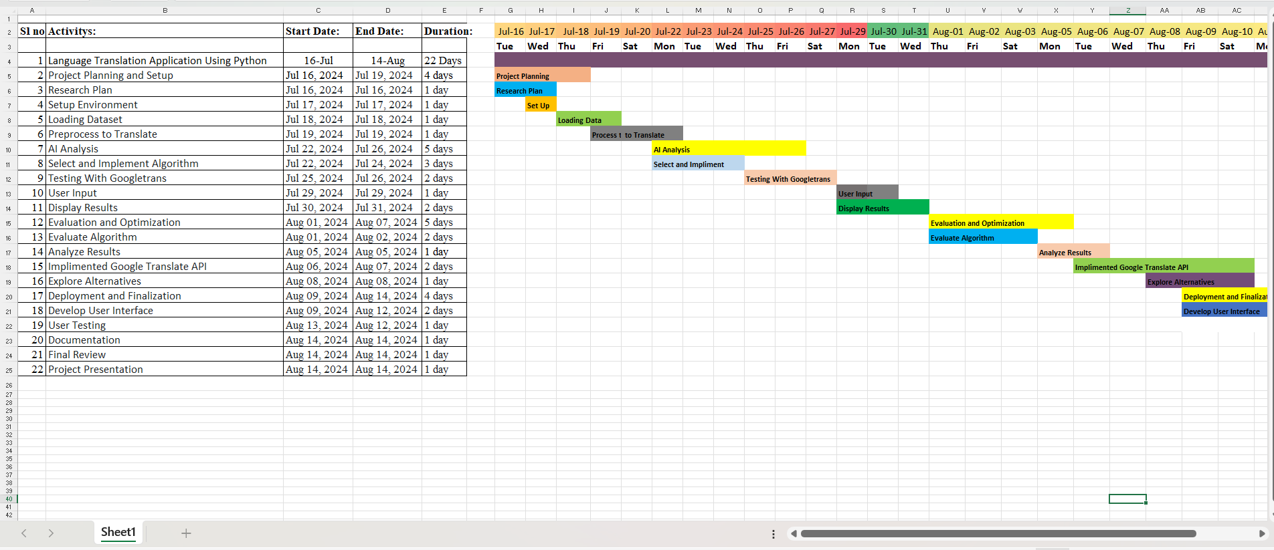

**METHODOLOGY**

3.1. googletrans

Googletrans is a free and unlimited python library that implemented Google Translate API. This uses the Google Translate Ajax API to make calls to such methods as detect and translate. It provides many features as follows:

1. Auto language detection

2. Fast and reliable

3. Customizable service URL

4. Bulk translations

3.2. Working

To begin with, we can either input the language code or input" options" keyword to get the list of languages and their respective code. After inputting the language code, translator will ask you to enter the text that you want to translate. Translator will automatically detect the language the user has inputted. And, after that it will show you the translation and pronounciation of the text into that language. In order to exit the program, we have to input "close" in the terminal and we will exit the program successfully.

**IMPLEMENTENTION**

from tkinter import *

from tkinter import ttk

from googletrans import Translator, LANGUAGES

# Initialize the main window

root = Tk()

root.geometry('1080x400')

root.resizable(0, 0)

root.config(bg='ghost white')

root.title("Language Translator")

# Add title and label

Label(root, text="LANGUAGE TRANSLATOR", font="arial 20 bold", bg='white smoke').pack()

Label(root, text="Python Project", font='arial 15 bold', bg='white smoke', width='20').pack(side='bottom')

Label(root, text="Enter Text", font='arial 13 bold', bg='white smoke').place(x=200, y=60)

# Input text box

Input text = Text(root, font='arial 10', height=11, wrap=WORD, padx= 5,pady=5, width=60)

Input text. place(x=30, y=100)

# Output text box

Label(root, text="Output", font='arial 13 bold', bg='white smoke').place(x=780, y=60)

Output text = Text(root, font='arial 10', height=11, wrap=WORD, padx=5, pady=5, width=60)

Output text. place(x=600, y=100)

# Language selection dropdowns

language = list(LANGUAGES.values())

src_lang = ttk.Combobox(root, values=language, width=22)

src_lang.place(x=20, y=60)

src_lang.set('choose input language')

dest_lang = ttk.Combobox(root, values=language, width=22)

dest_lang.place(x=890, y=60)

dest_lang.set('choose output language')

# Translation function

def Translate():

translator = Translator()

src_language = src_lang.get()

dest_language = dest_lang.get()

src_code = list(LANGUAGES.keys())[list(LANGUAGES.values()).index(src_language)]

dest_code = list(LANGUAGES.keys())[list(LANGUAGES.values()).index(dest_language)]

text = Input_text.get(1.0, END)

translated = translator.translate(text, src=src_code, dest=dest_code)

Output_text.delete(1.0, END)

Output_text.insert(END, translated.text)

# Translate button

trans_btn = Button(root, text='Translate', font='arial 12 bold', pady=5, command=Translate, bg='royal blue1', activebackground='sky blue')

trans_btn.place(x=490, y=180)

# Run the main loop

root.mainloop()

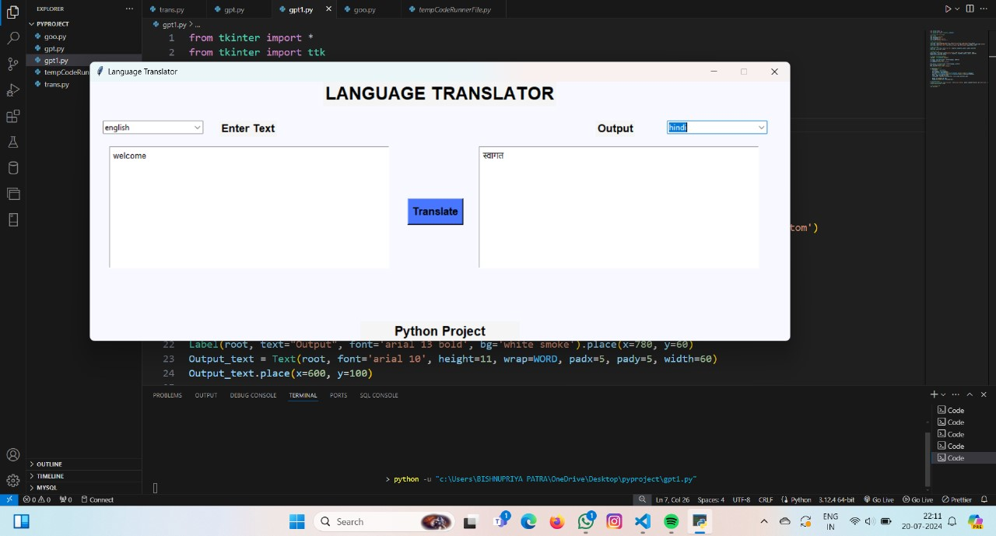

**CONCLUSION AND FUTURE SCOPE OF PROJECT**

The mini project on a language translator using Python successfully demonstrates the basic functionality of translating text from one language to another using a command-line interface (CLI) and an external translation API. The project leverages the googletrans library to interact with the Google Translate API, providing a straightforward and effective translation solution.

**Key Achievements:**

* **Simple and Effective UI:** The command-line interface allows for easy user interaction, making the translation process straightforward and accessible.
* **Integration with Google Translate API:** Utilizing the Google Translate API ensures high-quality translations and support for numerous languages.
* **Minimal Setup:** The project requires minimal setup, making it suitable for quick implementation and testing.

**Limitations:**

* **Dependency on External API:** The project relies on the Google Translate API, which may have usage limits and requires internet access.
* **Basic Error Handling:** The project includes basic error handling, but more robust error management could improve reliability.
* **Limited Functionality:** The current implementation focuses solely on text translation and does not support advanced features like speech translation or translation memory.

**Future Scope**

There are several directions in which the project can be expanded and improved:

1. **User Interface Enhancements:**
   * **Web Interface:** Develop a web-based interface using frameworks like Flask or Django to make the translator more user-friendly and accessible via web browsers.
   * **Mobile Application:** Create a mobile application for on-the-go translations.
2. **Speech Translation:**
   * Integrate speech recognition and text-to-speech capabilities using libraries like SpeechRecognition and pyttsx3 to support voice-based input and output.
3. **Offline Translation:**
   * Implement offline translation capabilities using pre-trained models from libraries like Hugging Face's Transformers, enabling translations without internet access.
4. **Enhanced Error Handling:**
   * Develop more robust error handling and logging mechanisms to improve reliability and user experience.
5. **Support for Multiple Translation APIs:**
   * Integrate with other translation APIs such as Microsoft Azure Translator or DeepL to provide alternatives and handle API rate limits effectively.
6. **Translation Memory:**
   * Implement a translation memory system to store and reuse previously translated segments, improving efficiency and consistency in translations.
7. **Performance Optimization:**
   * Optimize the translation engine for faster response times and better performance, especially for large texts.
8. **Customization and Personalization:**
   * Allow users to save their preferences and customize the translation experience, such as choosing specific dialects or formal/informal translations.

By addressing these future enhancements, the language translator project can evolve into a more comprehensive and versatile tool, catering to a broader range of users and use cases. The project has significant potential for growth and can serve as a foundation for more advanced translation solutions.